CUDGEWA MURAL TRAIL EXPRESSION OF INTEREST

Thank you for your interest in this Mural Trail along 2km of the old railway line from Cudgewa township to Wabba Creek.

Lodgement Date | Midnight Sunday 14 August 2022
Lodgement Method | info@parklands-alburywodonga.org.au (preferred)  or P O Box 1040, Wodonga VIC 3689

RESPONDENT DETAILS
Artist Name
ABN
Postal Address
Email Address
Telephone
Date able to supply
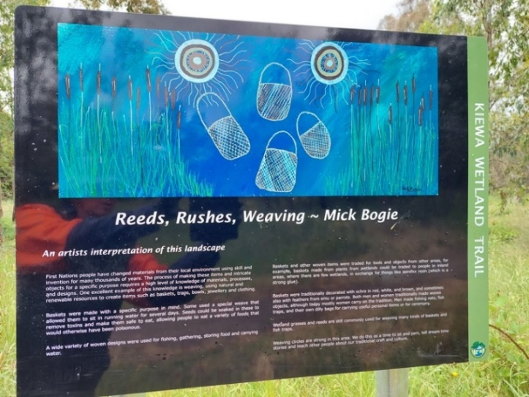
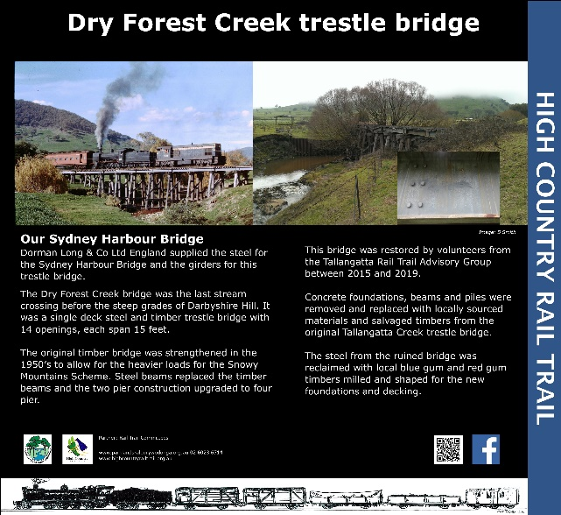

Some current examples of trail artwork
PROPOSED THEMES FOR ARTWORK

These are just some of the story themes gathered at the recent meeting.  If you have another type of story, please list below | Please add your name against your preferred story | Art, Photo, Poetry, Story? Please indicate your  preferred  contribution  A, Ph, P, S
Cudgewa – kangaroo skin
Cudgewa Station
Rabbit catcher hut
Old Hay Shed – 1885 A-frame building
Loading cattle onto train
300 year old Red Gum Tree and fire coming over Wabba Gap
Platypus
Early morning steam trains then diesel trains
Train break downs on sharp S-bend
One of largest inland cattle terminus in Australia
Cudgewa to Cairo song
Working for the railways - shovelling super phosphate and bricks
Cudgewa fire brigade – fire a significant role in history of Cudgewa
Wabba Station horses and Light Horse Brigade
The “Better farming train”, the “arts train” – leaning how to do pottery and silverwork
Snowy Hydro gantry at Cudgewa Station
44 train carriages of cattle a day
Cudgewa characters throughout the years
Railway driver stories
Deep snow when building old railway cottages
“Homecoming”, the view as cross Wabba Gap back to Cudgewa
Leaving the fog at Corryong and arriving to the sun over Cudgewa
Views from Cudgewa to the Snowy Mountains (local resident has some stunning photos)
Wildflowers
1974 Lady M butterflies
Perrons tree frog
Cudgewa Avenue of Honour
Snowy Irrigation Scheme – things declined from being lively and energetic
Old buildings built from timber harvested locally
No motor vehicles for 100 years. Mail depot created focal point
Horses and bullock carts travelling through “The Needles”
Cattle being walked down from the mountains to Cudgewa

OTHER IDEAS FOR ARTWORK / STORIES? Tell us about what story you wish to share?

